SAFETY DATA SHEET
Exotica Water Lily
According to Preparation of Safety Data Sheets for Hazardous Chemicals Code of Practice, February 2016

SECTION 1: Identification: Product identifier and chemical identity

Product identifier
Product name Exotica Water Lily

Internal identification EXOTWL
Relevant identified uses of the substance or mixture and uses advised against Application Premium room deodorant
Uses advised against No specific uses advised against are identified.

Details of the supplier of the safety data sheet
Supplier Sampson Chemical Products 42 Redcliffe Gardens Drive Clontarf, QLD, 4019
+61 7 3283 4511
sampson_office@bigpond.com
Contact Person Poisons Information 131126 or Brennan Stark 0428 835 855 Manufacturer Eco Pro Australia Pty Ltd
42 Redcliffe Gardens Drive, Clontarf, QLD, 4019
+61 7 3283 4511
sampson_office@bigpond.com

Emergency telephone number
Emergency telephone Poisons Information 131126 or Brennan Stark 0428 835 855
SECTION 2: Hazard(s) identification

Classification of the substance or mixture
Physical hazards Flam. Liq. 2 - H225
Health hazards Eye Irrit. 2A - H319 Environmental hazards Not Classified Label elements

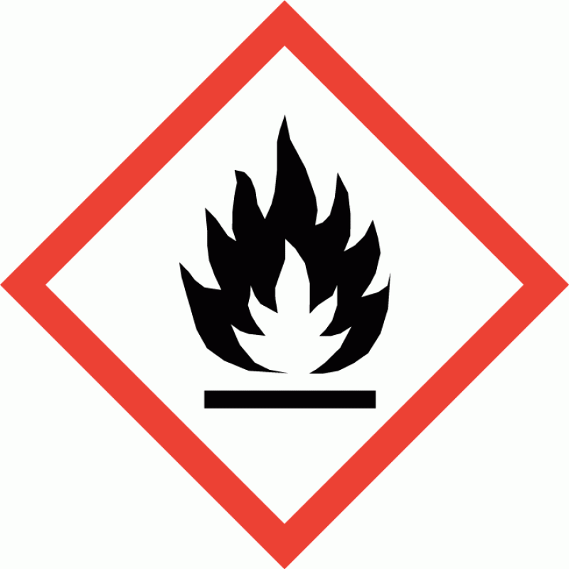
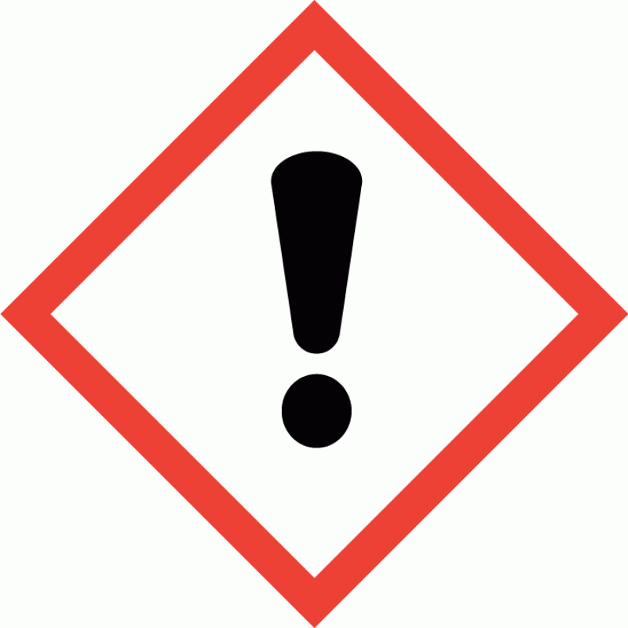
Hazard pictograms
Signal word DANGER
Hazard statements H225 Highly flammable liquid and vapour.
H319 Causes serious eye irritation.

Exotica Water Lily

Precautionary statements P210 Keep away from heat/ sparks/ open flames/ hot surfaces. - No smoking.
P233 Keep container tightly closed.
P240 Ground/ bond container and receiving equipment. P241 Use explosion-proof electrical equipment.
P242 Use only non-sparking tools.
P243 Take precautionary measures against static discharge. P264 Wash contaminated skin thoroughly after handling.
P280 Wear protective gloves/ protective clothing/ eye protection/ face protection. P303+P361+P353 IF ON SKIN (or hair): Take off immediately all contaminated clothing. Rinse skin with water/ shower.
P305+P351+P338 IF IN EYES: Rinse cautiously with water for several minutes. Remove contact lenses, if present and easy to do. Continue rinsing.
P337+P313 If eye irritation persists: Get medical advice/ attention.
P370+P378 In case of fire: Use foam, carbon dioxide, dry powder or water fog for extinction. P403+P235 Store in a well-ventilated place. Keep cool.
P501 Dispose of contents/ container in accordance with national regulations.

Other hazards
This product does not contain any substances classified as PBT (persistent, bioaccumulative and toxic) or vPvB (very persistent and very bioaccumulative).
SECTION 3: Composition and information on ingredients

Mixtures
Ethanol
CAS number: 64-17-5
>60%
SECTION 4: First aid measures
Description of first aid measures
General information If in doubt, get medical attention promptly. Show this Safety Data Sheet to the medical personnel.
Inhalation Move affected person to fresh air and keep warm and at rest in a position comfortable for breathing. Loosen tight clothing such as collar, tie or belt. Get medical attention if symptoms are severe or persist.
Ingestion Rinse mouth thoroughly with water. Get medical advice/attention if you feel unwell. Do not induce vomiting unless under the direction of medical personnel.
Skin Contact Rinse with water.
Eye contact Rinse with water. Get medical attention if any discomfort continues.
Protection of first aiders First aid personnel should wear appropriate protective equipment during any rescue. Most important symptoms and effects, both acute and delayed
General information The severity of the symptoms described will vary dependent on the concentration and the length of exposure.
Inhalation No specific symptoms known.
Ingestion No specific symptoms known.
Skin contact No specific symptoms known.
Eye contact No specific symptoms known. May be slightly irritating to eyes. Indication of any immediate medical attention and special treatment needed

Exotica Water Lily

Notes for the doctor Treat symptomatically.
SECTION 5: Firefighting measures

Extinguishing media
Suitable extinguishing media The product is flammable. Extinguish with alcohol-resistant foam, carbon dioxide, dry powder or water fog. Use fire-extinguishing media suitable for the surrounding fire.

Unsuitable extinguishing media
Do not use water jet as an extinguisher, as this will spread the fire.

Special hazards arising from the substance or mixture
Specific hazards Containers can burst violently or explode when heated, due to excessive pressure build-up. Flammable liquid and vapour. Vapours may be ignited by a spark, a hot surface or an ember. Vapours may form explosive mixtures with air. Fire-water run-off in sewers may create fire or explosion hazard.

Hazardous combustion products
Advice for firefighters
Protective actions during firefighting

Special protective equipment for firefighters
Thermal decomposition or combustion products may include the following substances: Harmful gases or vapours.

Avoid breathing fire gases or vapours. Evacuate area. Cool containers exposed to heat with water spray and remove them from the fire area if it can be done without risk. Cool containers exposed to flames with water until well after the fire is out. If a leak or spill has not ignited, use water spray to disperse vapours and protect men stopping the leak. Control run-off water by containing and keeping it out of sewers and watercourses. If risk of water pollution occurs, notify appropriate authorities.
Wear positive-pressure self-contained breathing apparatus (SCBA) and appropriate protective clothing. Firefighter's clothing conforming to Australia/New Zealand Standards AS/NZS 4967 (for clothing) AS/NZS 1801 (for helmets), AS/NZS 4821 (for protective boots), AS/NZS 1801 (for protective gloves) will provide a basic level of protection for chemical incidents.

Hazchem Code •2YE
SECTION 6: Accidental release measures

Personal precautions, protective equipment and emergency procedures
Personal precautions Wear protective clothing as described in Section 8 of this safety data sheet. No action shall be taken without appropriate training or involving any personal risk. Evacuate area. Provide adequate ventilation. No smoking, sparks, flames or other sources of ignition near spillage.
Promptly remove any clothing that becomes contaminated.

Environmental precautions
Environmental precautions Avoid discharge into drains or watercourses or onto the ground.

Methods and material for containment and cleaning up
Methods for cleaning up Wear protective clothing as described in Section 8 of this safety data sheet. Clear up spills immediately and dispose of waste safely. Eliminate all ignition sources if safe to do so. No smoking, sparks, flames or other sources of ignition near spillage. Do not allow material to enter confined spaces, due to the risk of explosion. Absorb small quantities with paper towels and evaporate in a safe place. Once evaporation is complete, place paper in a suitable waste disposal container and seal securely. Flush contaminated area with plenty of water. Wash thoroughly after dealing with a spillage. For waste disposal, see Section 13.
Reference to other sections

Exotica Water Lily

Reference to other sections For personal protection, see Section 8. See Section 11 for additional information on health hazards. See Section 12 for additional information on ecological hazards. For waste disposal, see Section 13.
SECTION 7: Handling and storage, including how the chemical may be safely used

Precautions for safe handling
Usage precautions Read and follow manufacturer's recommendations. Wear protective clothing as described in Section 8 of this safety data sheet. Keep away from food, drink and animal feeding stuffs.
Handle all packages and containers carefully to minimise spills. Keep container tightly sealed when not in use. Avoid the formation of mists. The product is flammable. Keep away from heat, hot surfaces, sparks, open flames and other ignition sources. No smoking. Do not handle until all safety precautions have been read and understood. Do not handle broken packages without protective equipment. Do not reuse empty containers.

Advice on general occupational hygiene
Wash promptly if skin becomes contaminated. Take off contaminated clothing and wash before reuse. Wash contaminated clothing before reuse.

Conditions for safe storage, including any incompatibilities
Storage precautions Keep away from oxidising materials, heat and flames. Keep only in the original container.
Keep container tightly closed, in a cool, well ventilated place. Keep containers upright. Protect containers from damage.
Storage class Flammable liquid storage.

Specific end use(s)
Specific end use(s) The identified uses for this product are detailed in Section 1.
SECTION 8: Exposure controls and personal protection

Control parameters Occupational exposure limits Ethanol
Long-term exposure limit (8-hour TWA): 1000 ppm 1880 mg/m³

Exposure controls Protective equipment

Appropriate engineering controls
Provide adequate ventilation. Observe any occupational exposure limits for the product or ingredients.

Eye/face protection Unless the assessment indicates a higher degree of protection is required, the following protection should be worn: Tight-fitting safety glasses.
Hand protection No specific hand protection recommended.

Other skin and body protection
Wear appropriate clothing to prevent repeated or prolonged skin contact.

Hygiene measures Wash hands thoroughly after handling. Wash at the end of each work shift and before eating, smoking and using the toilet. Do not eat, drink or smoke when using this product.

Exotica Water Lily

Respiratory protection Ensure all respiratory protective equipment is suitable for its intended use and complies with Australia/New Zealand Standard AS/NZS 1716. Check that the respirator fits tightly and the filter is changed regularly. Gas and combination filter cartridges should comply with Australia/New Zealand Standard AS/NZS 1716. Full face mask respirators with replaceable filter cartridges should comply with Australia/New Zealand Standard AS/NZS 1716. Half mask and quarter mask respirators with replaceable filter cartridges should comply with Australia/New Zealand Standard AS/NZS 1716.

Environmental exposure controls
Keep container tightly sealed when not in use.

SECTION 9: Physical and chemical properties

Information on basic physical and chemical properties Appearance Clear liquid.
Colour Clear.
Odour Water lily

Specific Gravity 0.79
Initial boiling point and range 78°C Flash point 11-13°C
Vapour pressure 5.9 kPa @ 24°C Auto-ignition temperature 422°C
SECTION 10: Stability and reactivity
Reactivity There are no known reactivity hazards associated with this product.
Stability Stable at normal ambient temperatures and when used as recommended. Stable under the prescribed storage conditions.

Possibility of hazardous reactions
The following materials may react strongly with the product: Oxidising agents.

Conditions to avoid Avoid heat, flames and other sources of ignition. Containers can burst violently or explode when heated, due to excessive pressure build-up. Static electricity and formation of sparks must be prevented.
Materials to avoid Oxidising materials. Acids - oxidising.

Hazardous decomposition products
Does not decompose when used and stored as recommended. Thermal decomposition or combustion products may include the following substances: Harmful gases or vapours.

SECTION 11: Toxicological information

Information on toxicological effects Acute toxicity - oral
Summary Ingestion of material may be damaging to health; ingestion may produce nausea, vomiting,
gastrointestinal bleeding, abdominal pain and diarrhoea.
Notes (oral LD₅₀) Based on available data the classification criteria are not met. Acute toxicity - dermal
Notes (dermal LD₅₀) Based on available data the classification criteria are not met.

Exotica Water Lily

Acute toxicity - inhalation
Notes (inhalation LC₅₀) Based on available data the classification criteria are not met.

Skin corrosion/irritation
Summary The material may produce moderate skin irritation. Skin irritation may be present after prolonged or repeated exposure; this may result in a form of contact dermitits. (nonallergic)
Animal data Based on available data the classification criteria are not met.

Serious eye damage/irritation
Serious eye damage/irritation Based on available data the classification criteria are not met.

Respiratory sensitisation
Respiratory sensitisation Based on available data the classification criteria are not met.

Skin sensitisation
Skin sensitisation Based on available data the classification criteria are not met.

Germ cell mutagenicity
Genotoxicity - in vitro Based on available data the classification criteria are not met.

Carcinogenicity
Carcinogenicity Based on available data the classification criteria are not met.
IARC carcinogenicity Contains a substance/a group of substances which may cause cancer. IARC Group 1 Carcinogenic to humans.

Reproductive toxicity
Reproductive toxicity - fertility Based on available data the classification criteria are not met.

Reproductive toxicity - development
Based on available data the classification criteria are not met.

Specific target organ toxicity - single exposure
STOT - single exposure Not classified as a specific target organ toxicant after a single exposure.

Specific target organ toxicity - repeated exposure
STOT - repeated exposure Not classified as a specific target organ toxicant after repeated exposure.

Aspiration hazard
Aspiration hazard Based on available data the classification criteria are not met.

General information The severity of the symptoms described will vary dependent on the concentration and the length of exposure.
Inhalation No specific symptoms known.
Ingestion No specific symptoms known.
Skin Contact No specific symptoms known.
Eye contact No specific symptoms known.
Route of exposure Ingestion Inhalation Skin and/or eye contact Target Organs No specific target organs known.
SECTION 12: Ecological information

Exotica Water Lily

Ecotoxicity Not regarded as dangerous for the environment. However, large or frequent spills may have hazardous effects on the environment.
Toxicity Based on available data the classification criteria are not met. Persistence and degradability
Persistence and degradability The degradability of the product is not known.

Bioaccumulative potential
Bioaccumulative Potential No data available on bioaccumulation.

Mobility in soil
Mobility No data available.

Other adverse effects
Other adverse effects None known.
SECTION 13: Disposal considerations

Waste treatment methods
General information The generation of waste should be minimised or avoided wherever possible. Reuse or recycle products wherever possible. This material and its container must be disposed of in a safe way. When handling waste, the safety precautions applying to handling of the product should be considered. Care should be taken when handling emptied containers that have not been thoroughly cleaned or rinsed out. Empty containers or liners may retain some product residues and hence be potentially hazardous.
Disposal methods Dispose of surplus products and those that cannot be recycled via a licensed waste disposal contractor. Waste, residues, empty containers, discarded work clothes and contaminated cleaning materials should be collected in designated containers, labelled with their contents. Incineration or landfill should only be considered when recycling is not feasible.
SECTION 14: Transport information

General For limited quantity packaging/limited load information, consult the relevant modal documentation using the data shown in this section.

UN number
UN No. (ADG) 1170
UN No. (IMDG) 1170
UN No. (ICAO) 1170
UN proper shipping name
Proper shipping name (ADG) ETHANOL (ETHYL ALCOHOL) or ETHANOL SOLUTION (ETHYL ALCOHOL SOLUTION)

Proper shipping name (IMDG)
ETHANOL (ETHYL ALCOHOL) or ETHANOL SOLUTION (ETHYL ALCOHOL SOLUTION)

Proper shipping name (ICAO) ETHANOL (ETHYL ALCOHOL) or ETHANOL SOLUTION (ETHYL ALCOHOL SOLUTION)
Transport hazard class(es)
ADG class 3
ADG classification code F1
ADG label 3

Exotica Water Lily

IMDG class 3
ICAO class/division 3
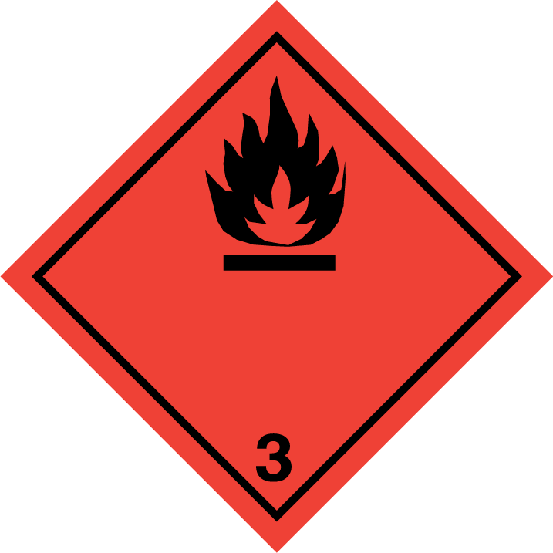
Transport labels

Packing group

ADG packing group II

IMDG packing group II

ICAO packing group II
Environmental hazards
Environmentally hazardous substance/marine pollutant No.
Special precautions for user
Always transport in closed containers that are upright and secure. Ensure that persons transporting the product know what to do in the event of an accident or spillage.
EmS F-E, S-D
Hazchem Code •2YE

Transport in bulk according to Annex II of MARPOL 73/78 and the IBC Code
Not applicable.

SECTION 15: Regulatory information

Inventories Australia - AICS
None of the ingredients are listed or exempt.
SECTION 16: Any other relevant information

Training advice Only trained personnel should use this material.
Revision date 17/05/2021

Revision 3
Supersedes date 17/05/2021
SDS No. 4744
General Information The following risk and hazard statements are to be considered a glossary. They relate to the raw materials used in this product and therefore may not be accurate for the finished product itself. For the complete risk and hazard statements for this product please refer to section 2 of this Safety Data Sheet
Hazard statements in full H225 Highly flammable liquid and vapour.
H319 Causes serious eye irritation.

Exotica Water Lily

This information relates only to the specific material designated and may not be valid for such material used in combination with any other materials or in any process. Such information is, to the best of the company's knowledge and belief, accurate and reliable as of the date indicated. However, no warranty, guarantee or representation is made to its accuracy, reliability or completeness. It is the user's responsibility to satisfy himself as to the suitability of such information for his own particular use.

